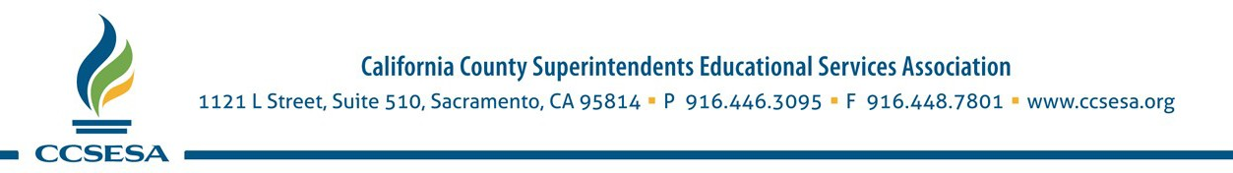

CCSESA JOB ANNOUNCEMENT
Job Title: Manager, Administration & Operations

Summary of the Position:
Provide support to the Finance, Audit and Business Partnership committees including meeting planning and agenda development; managing association contracts; bookkeeping of association finances; provide general office management including supervision of support staff; and perform other general administrative support to key association staff.

Skills/Qualifications Required:
- Excellent organizational and inter-personal skills.
- Bookkeeping experience
- Proficient in QuickBooks and Microsoft Office software including Word, Excel, PowerPoint, Outlook.

Compensation:
Salary range is $60,000.00-$90,000.00 depending on experience. CCSESA offers an excellent benefits package including health and retirement plans. Downtown Sacramento parking pass or monthly public transit pass will be provided.

About CCSESA:
The California County Superintendents Educational Services Association (CCSESA) is a statewide non- profit organization with the mission of strengthening the service and leadership capabilities of California’s 58 county superintendents in support of students and school districts. Through CCSESA, county superintendents are organized statewide to work closely with state agencies to implement education programs effectively and efficiently in response to statutory requirements and the needs of districts and schools. CCSESA works with state policymakers including the Governor, Legislature, State Board of Education, and the California Department of Education to ensure that the statutory responsibilities of the county superintendents are carried out in a consistent and equitable manner across the state.

How to Apply:
Please send a resume and cover letter describing your interest and relevant experience to: Peter Birdsall, CCSESA Executive Director at pbirdsall@ccsesa.org

October 5, 2018

