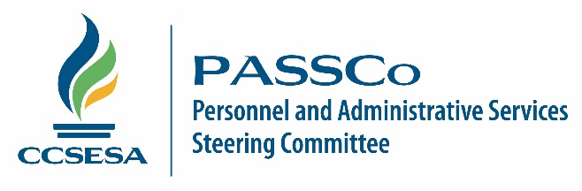

General Session Meeting Calendar

2017 Meeting Dates

February 2-3, 2017

May 11-12, 2017

August 24-25, 2017

November 16-17, 2017

2018 Meeting Dates

February 1-2, 2018

May 17-18, 2018

September 6-7, 2018

November 15-16, 2018

Meeting Location

Yolo County Office of Education
1280 Santa Anita Court, Suite 100
Woodland, CA 95776-6127
(530) 668-6700

