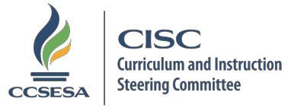

ELA/ELD CISC SUBCOMMITTEE 2017-18 MEETING SCHEDULE

2017
July (No Meeting)
August 8 (cancelled)
September 12
October 13 – (Face-to-Face)
November 14
December 12
2018
January 9
February 13
March 13
April 10
May 8
June 12

AGENDA

8:30-9:30 a.m. Workgroups
(Independently organized)

9:30-10:30 a.m. General Subcommittee Webinar 10:30-11:00 a.m. ERWC
CISC ELA/ELD Subcommittee Dropbox Folder Link: https://www.dropbox.com/sh/my1hbcrvurq5a4k/AAC_RB5dkROlCzfeERd3O9PTa?dl=0

Updated May 4, 2017

