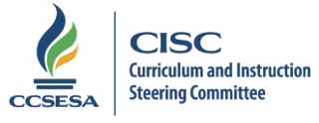
2015 CISC Subcommittee Members

Mathematics | Region | County | Email
Rick Bartkowski | 6 | Stanislaus | rbartkowski@stancoe.org | Lead
Ellen Barger | 8 | Santa Barbara | ebarger@sbceo.org | Co-lead
Josh Dies | 1 | Sonoma | jdeis@scoe.org
Chris Dell | 2 | Shasta | cdell@shastacoe.org
Dave Chun | 3 | Sacramento | dchun@scoe.net
Katie Rhee | 4 | San Mateo | krhee@smcoe.org
Linda Dilger | 5 | Monterey | ldilger@monterey.k12.ca.us
Erin Cross | 6 | Stanislaus | ecross@stancoe.org
Kathy Woods | 7 | Madera | kwoods@maderacoe.k12.ca.us
Vicki Vierra | 8 | Ventura | vvierra@vcoe.org
Jody Guarino | 9 | Orange | jguarinoa@ocde.us
Vicki Kukuruda | 10 | Riverside | vlkukuruda@rcoe.us
Anthony Quan | 11 | Los Angeles | Quan_anthony@lacoe.org

9.10.15/lb

