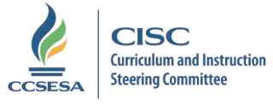

2016-17 Mathematics Subcommittee Members

Member | Region | County | Email
Ellen Barger | 8 | Santa Barbara | ebarger@sbceo.org | Lead
Antonio Castro | 8 | Ventura | acastro@vcoe.org | Co-Lead
Josh Deis | 1 | Sonoma | jdeis@scoe.org
Chris Dell | 2 | Shasta | cdell@shastacoe.org
David Chun | 3 | Sacramento | dchun@scoe.net
Christen Schwartz | 4 | Contra Costa | cschwartz@cccoe.k12.ca.us
Kirsten Sarginger | 5 | Santa Clara | Kirsten_sarginger@sccoe.org
Erin Cross | 6 | Stanislaus | ecross@stancoe.org
Julie Joseph | 7 | Tulare | Julie.Joseph@tcoe.org
Vicki Vierra | 8 | Ventura | vvierra@vcoe.org
Melinda Shacklett | 9 | San Diego | mshacklett@sdcoe.net
Vicky Kukuruda | 10 | Riverside | vlkukuruda@rcoe.us
Anthony Quan | 11 | Los Angeles | Quan_Anthony@lacoe.edu

